Project Design Phase-II Customer Journey Mapping

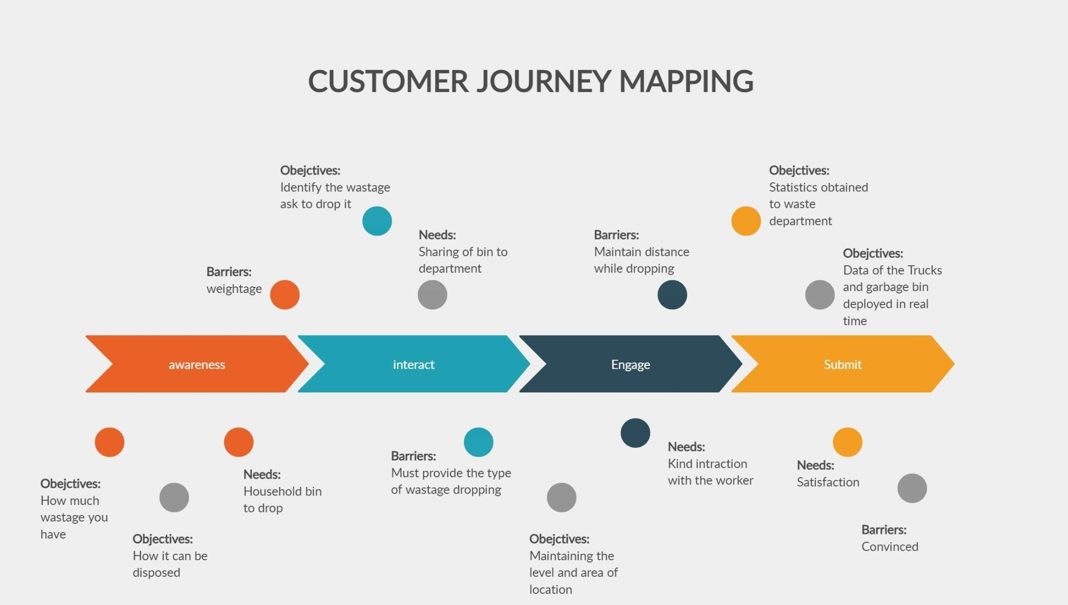

|  |  |
| --- | --- |
| Date | 08 October 2022 |
| Team ID | PNT2022TMID43251 |
| Project Name | Smart Waste Management System For Metropolitan Cities |
| Maximum Marks | 4 Marks |